Nd de
Terms 5 and 6 in Year 3 YEAR 3

Welcome to the summer terms in year 3,
Mrs Daniels and I were delighted to welcome Miss Wilkins to our year 3 team last term – she will continue to be with us 3 mornings a week (Mon to Weds) and has settled in fabulously. We are very lucky to have her.
This coming term, there are so many things to be excited for , that we will be learning about in year 3. Firstly, we hope to benefit from our outdoor forest school area this term and link the use of this wonderful resource to our topics where possible. We also have a trip to the Dover Museum planned (details to follow shortly) to support our learning about Romans and the impact they had on Britain. In addition to this, we will be having a visit from our French friends next week, not to mention a workshop paid for by for by our dedicated PTA, as well as the usual features of the summer term such as sports day, the summer fair and move up days to new classes in July.
Curriculum
We will continue to follow the National Curriculum for year 3. More information about the curriculum can be seen on the school website – http://www.eastry.kent.sch.uk/. Further details about this term’s learning can also be seen overleaf.
In terms of your child’s learning and progress, the best support you can give at home, is to make reading regularly to or with an adult, a priority. That adult needs to ask lots of questions about the reading / story. Putting reading at the heart of all home learning (daily where possible) will boost your child’s development in all areas of the curriculum. Making sure your child arrives in school on time, with the correct equipment for each day, will also help their day to run smoothly.
Home Learning
Home learning will continue be set using the grid system we started in January. We feel that giving children choice about the home learning, is positive and worthwhile. Children can hand in their home learning each week, recorded in their purple home learning book and /or signed off on the grid. The focus is on compulsory weekly activities: spellings; times tables; reading at home. Children without any evidence of these activities in their book by Tuesday, will be asked to attend home learning club on Wednesday lunchtime with Mrs Harvey. Mrs Daniels will continue to run mathletics club to give all children the opportunity to use this brilliant website, to develop maths skills. Attached to this sheet is the home learning schedule that details activities children can complete up to the summer holiday.

Equipment
Reminder...1 SMALL pencil case that fits into your child’s tray is plenty. Oversize / additional pencil cases will be sent home. Golden time will be on a Friday afternoon and children can bring in their own toys to play with. Toys on Tuesday, will continue, so on a Tuesday morning, children can bring a toy to play with at play times that day. We encourage you to keep children’s most precious toys at home in case they get lost or broken.
Water Bottles
Please help us by bringing bottles to school each day full of fresh water. They can then be taken home again each afternoon. We do not have ANY access to drinking water in the classroom. A bottle full of fresh water means we have fewer disruptions to the learning when children would like a drink during lesson time. Filling bottles and trips to the fountain are disruptive.
PE Full PE kit (blue/black shorts, white T shirt and trainers) needs to be in school at ALL times please. Many children in this class are without proper kit. Use of the forest school may require children to bring in wellies – we will keep you up to date with this possible requirement.
Literacy / Topic
We continue to link together as much of the children’s learning as possible, so our topic, art, dance, music and literacy overlap considerably. In term 5, the topic is ‘British resistance to Romans’ so we will write newspaper reports and recounts about Boudicca as well as reading the story Escape from Pompeii a link to both Romans and volcanoes. In term 6, we move onto life of Romans in Britain and the legacy they left us, so reading and writing will be around this theme.
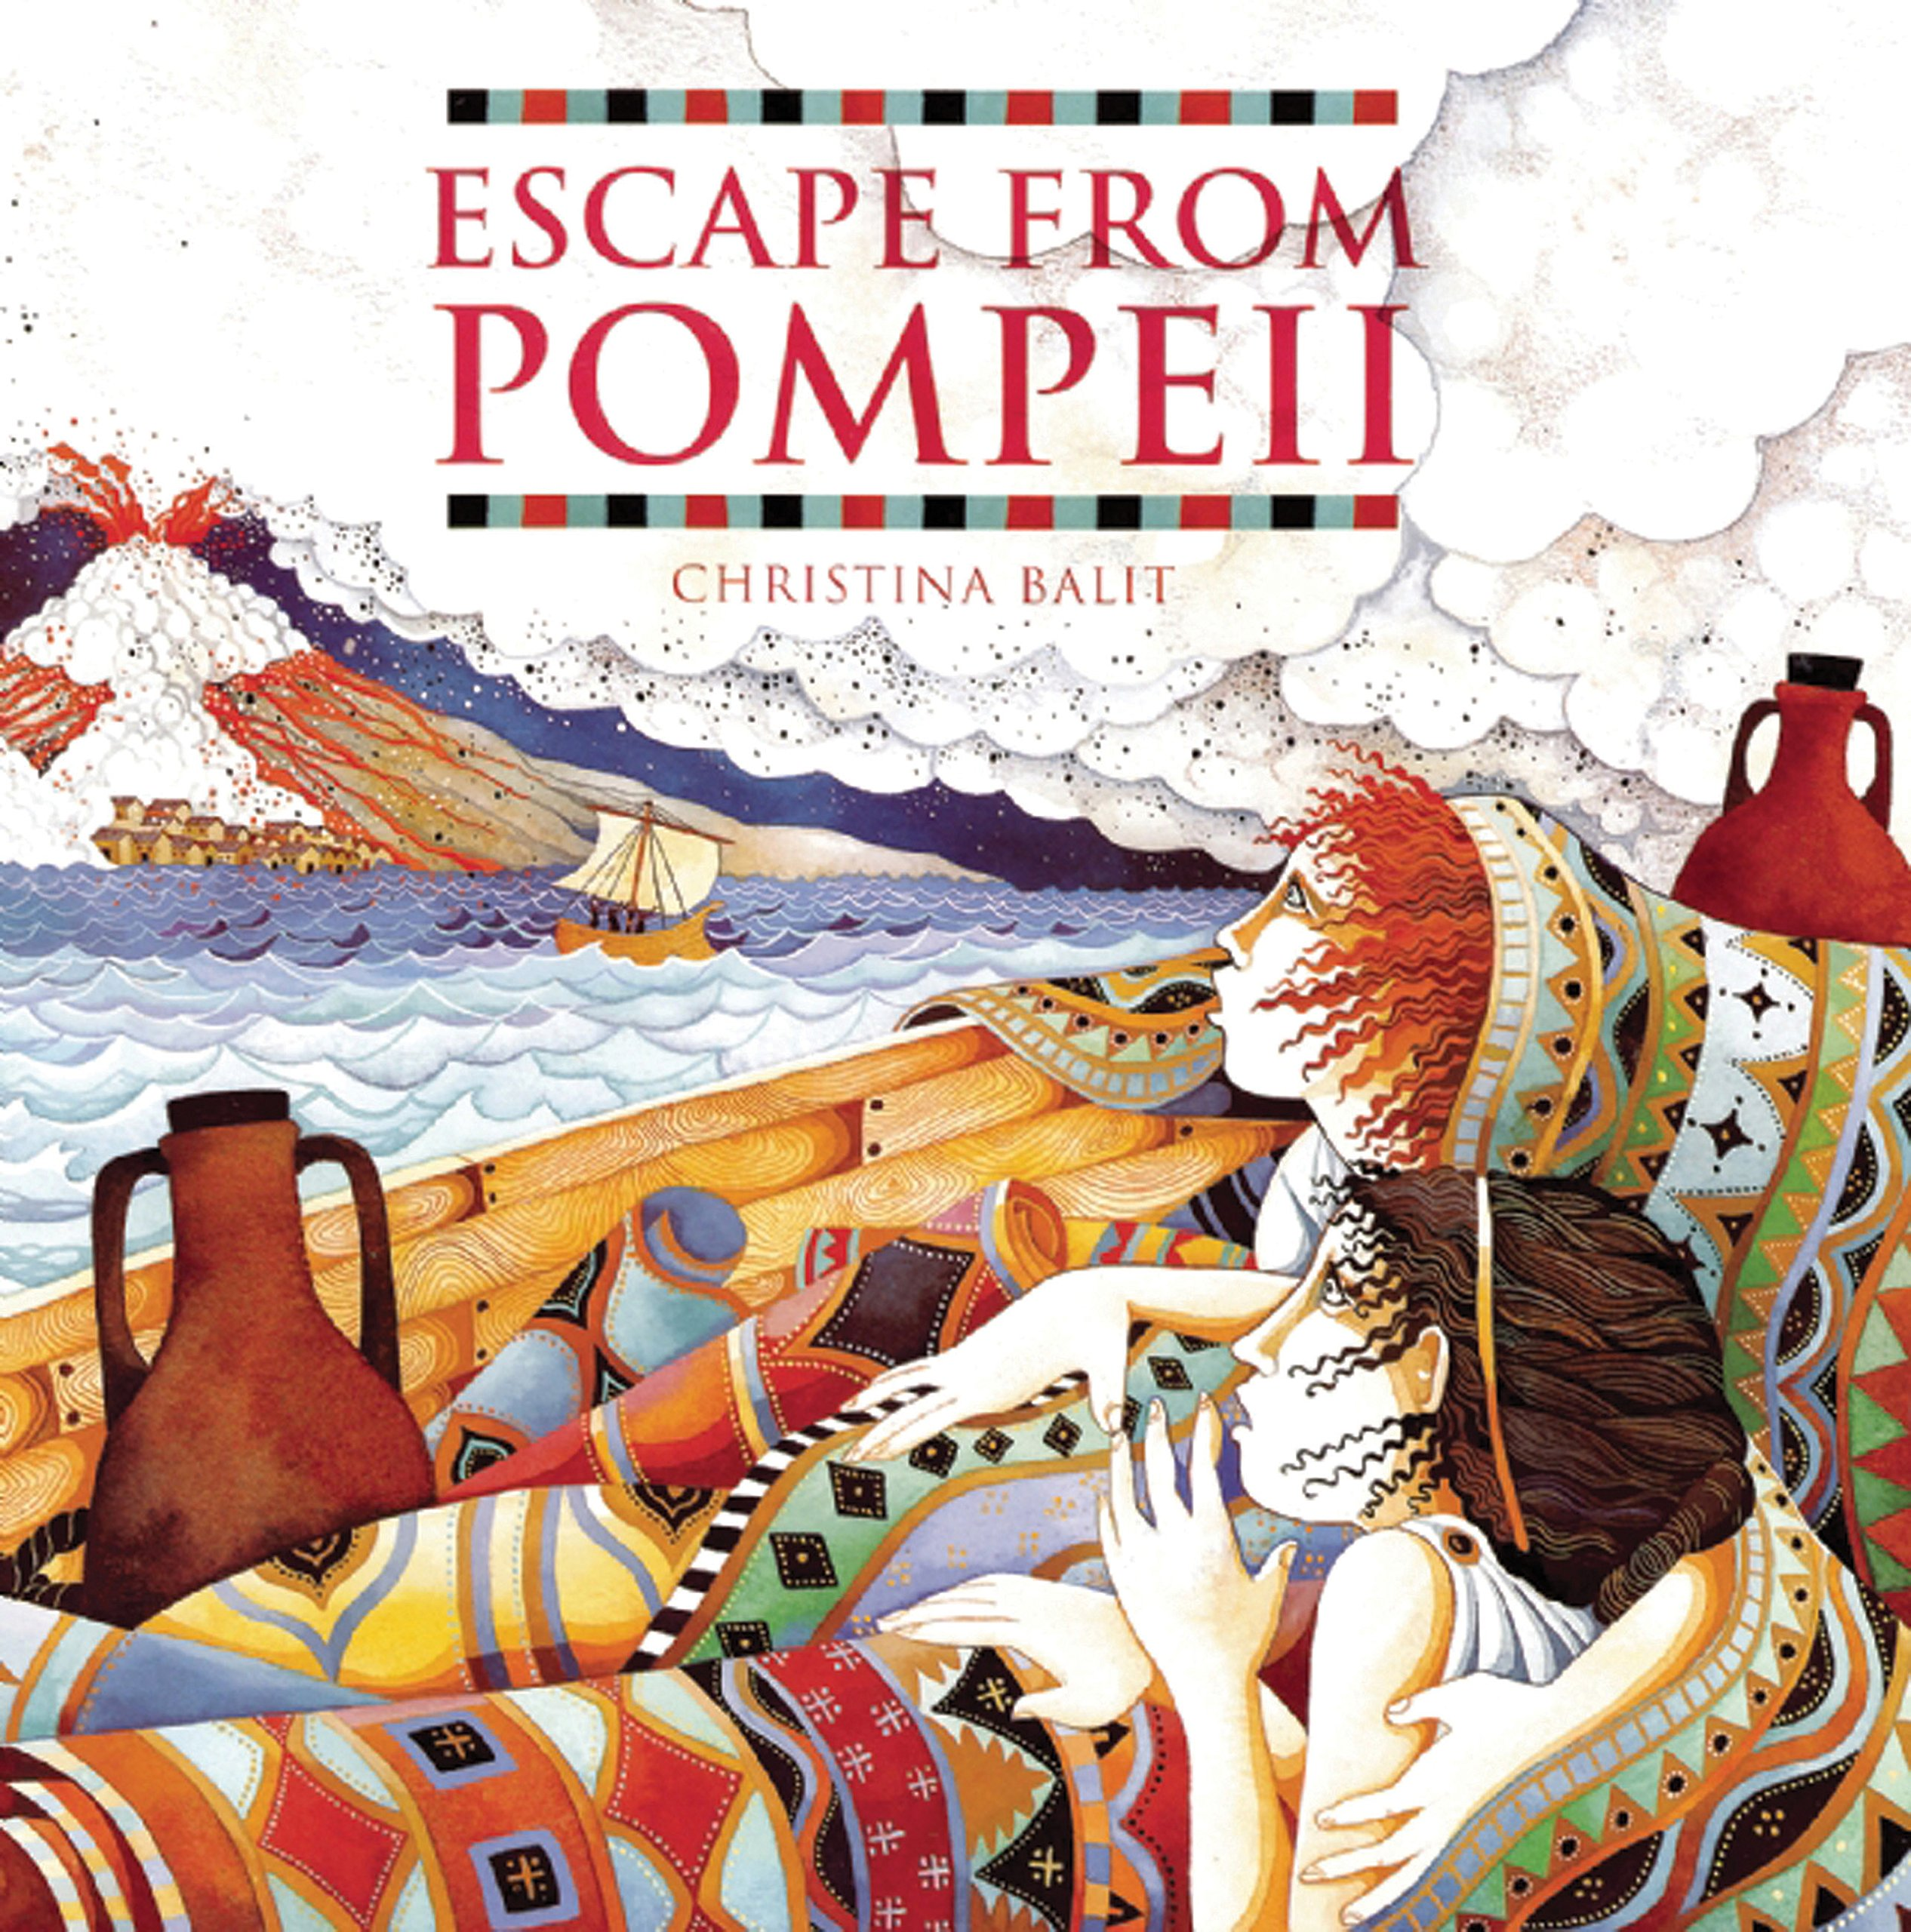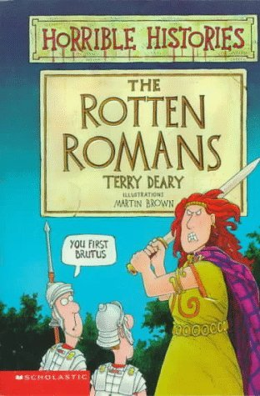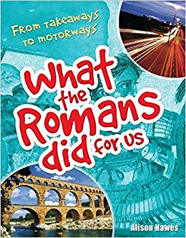

Numeracy
Revisit – addition and subtraction – 3 digit numbers in problems especially.
Revisit – multiplication – 2/3 digits by 1 digit – partitioning
Revisit – division – 2 digits by one digit
Times table fluency / as divisions
Shape (symmetry), angles, more measuring - capacity and weight.
Time and durations of time
Roman Numerals

1. Plants – part 2 – artful flowers, fruits and seeds

2. Light and shadows
Computing
E-safety
1.Making a short film
2.Topic research; copying and pasting pictures and power points
TERMS 5 AND 6

R.E.
KINGDOM OF GOD; When Jesus left, what was the impact of Pentecost?
SIKHISM; How do Sikhs worship and celebrate?

Games - striking and fielding; cricket, rounders athletics
Gym – linking moves – rolls / balance
Art / Design Technology
Observational drawing and painting flowers and fruits
Clay work
Roman mosaics and pattern
Moving Monsters
Personal, Social, Health Education
Apple’s Friends

French
How old am I? My family, days of the week, colours and things we do.
French life and lifestyle.
Music
Continue learning on pulse and rhythm.

Reading Journals
Please continue to encourage children to record their own reading alongside our comments and your comments, to make it a real record of ALL their reading. Also children can continue to write on their sign posts, listing the places their reading has taken them. If you have any questions, problems, or things to celebrate please do not hesitate to pop in and see us, or make a note in the contact book, so we can continue to work together in the best interests of your child. Thank you.
From the year 3 team.

