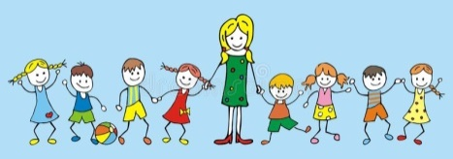
Nd de
WELCOME TO YEAR 3

Dear Parents, Carers and Children in year 3,
Welcome back! We hope you had a fun and restful summer. Mrs Daniels and I are very excited to be teaching the children in year 3. We are looking forward to working with you, helping your children to succeed in their learning and encouraging them to participate fully in school life. We hope to use stories to bring our topics alive and where possible will use practical activities to reinforce learning. Mrs Daniels and I will both be in year 3 full-time this term.
Curriculum
We will follow the National Curriculum for year 3. More information about the curriculum can be seen on the school website – perhaps you can make time to have a look at http://www.eastry.kent.sch.uk/. Further details about this term’s learning can also be seen overleaf.
We hope you will be able to support your child, by reading regularly at home with them (daily where possible), completing home learning and making sure your child arrives in school on time with the correct equipment for each day.
Home Learning
Home learning will be set according to the school policy and government guidelines, which both state that children in year 3, should have approximately 1.5 hours of home learning a week. This does include reading, just 10 minutes a day would benefit all children greatly.

Home learning activities will be given out on a Thursday afternoon and collected in by the following Tuesday. Usually, it will involve a short numeracy activity as well as a topic based / literacy activity. It will always reinforce class learning. If home learning has not been completed, children will be asked to attend home learning club on Wednesday lunchtime. If children complete home learning using the internet, please refer to E-Safety Information, seen on the school website and encourage them to adhere to the guidelines they have been taught in e-safety lessons.

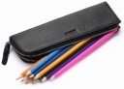
Equipment
Children in year 3 will be allowed to bring in a small pencil case containing a pencil, rubber, sharpener, ruler and a few colouring pencils and felt tips. This must fit comfortably in their tray. Golden time will be on a Friday afternoon and children can bring in their own toys to play with. Following the success of ‘Toys on Tuesday’, this will continue and on a Tuesday morning children can bring a toy to play with at play times that day. We encourage you to keep children’s most precious toys at home in case they get lost or broken.

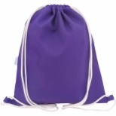
PE
Full PE kit (blue/black shorts, white T shirt and trainers) needs to be in school at ALL times please. There are times when we need to be flexible with the timetable so it’s important to have kit on pegs every day ‘just in case’.
Games will be on a Friday afternoon. In year 3 the children wear their school uniform to school in the mornings and change for their afternoon PE lesson in school.
We will be swimming some Tuesday mornings this term. More details of this (dates / cost) will follow in a separate letter soon. Our other PE slot (for dance or gym) is on a Wednesday afternoon.
Numeracy
Read, write, order, partition, compare hundreds, tens and ones (HT1 or HTU))
Estimate numbers
Number bonds of 10, 20, 100
Measure length in cm
Check U+U+U, TU+-U, TU+-10, +-TU
Count in steps 2, 5, 10, 50, 100
Money place; value £,10p,1p
Mental; HTU+U
Name 2D and 3D shapes
Time; hour half past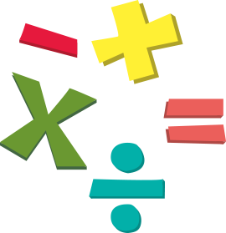
Literacy / Topic
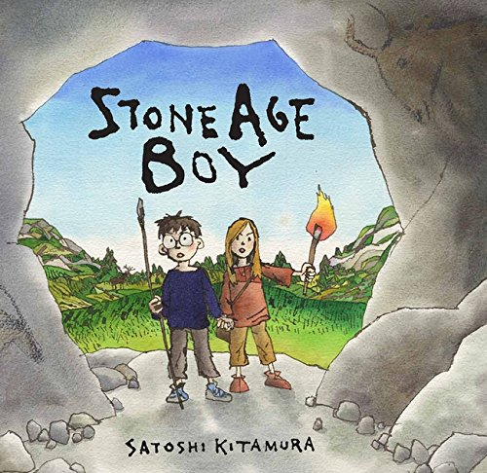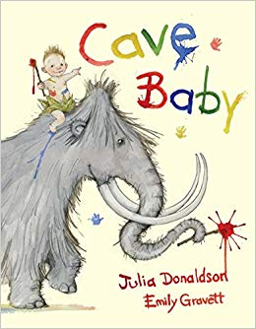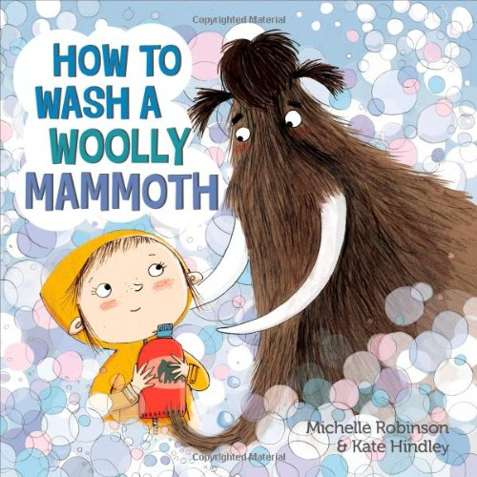
We will use stories ‘Stone Age Boy’, ‘How to Wash a Wooly Mammoth’ and ‘Cave Baby’ to tell stories and write stories with familiar settings, recounts, instructions, letters and poems. This will inform the learning in our history and geography units called ‘From Stone Age to Iron Age’.

E
TERMS 1 AND 2
1. Animals including humans-nutrition & skeleton/muscles
2. Rocks
Computing
E-safety
1. We are programmers. 2. We are bug fixers

R.E.

Discovering Christianity – People of God, Christmas

Games - invasion Swimming
Dance - hunters Gym - travelling
Personal, Social, Health Education
Apple’s Friends (Continued from Yr2, Zippy’s Friends)
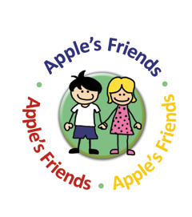
Art / Design Technology
Skull Art
Stone Age inspired art – e.g. cave paintings
Making Photo Frames
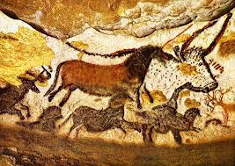

French
Hello:What is your name? Numbers to 20, How old am I? Happy Birthday / Christmas.
Music
Stone Age Rhythms

Each child will bring home a small contact book where we (school and home) can share information about your child where necessary. We will also record in school reading, in a Reading Journal. Please add to this when you hear your child read at home. If you have any questions or problems, please do not hesitate to pop in and see us, or make a note in the contact book, so issues can be resolved swiftly. Similarly, we would love to hear of children’s successes, so please share these with us too so they can be celebrated.

