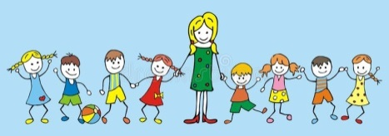
Nd de
HAPPY NEW YEAR! YEAR 3

Dear Parents, carers and children in year 3,
Welcome back everyone!! Firstly, may I take this opportunity to thank those who kindly brought in Christmas gifts at the end of last term, they were very much appreciated. I would have liked to thank each of you individually, however in the Christmas tidy up at home my list got misplaced (sorry!) We hope you also have had a lovely Christmas and New Year – let’s also hope 2019 at school, is full of new and interesting topics for your children. Terms 3 and 4 will, of course, build on the learning completed in terms 1 and 2.
Curriculum
We will continue to follow the National Curriculum for year 3. More information about the curriculum can be seen on the school website – http://www.eastry.kent.sch.uk/. Further details about this term’s learning can also be seen overleaf.
We hope you will be able to support your child, by reading regularly at home with them (daily where possible) and making sure your child arrives in school on time, with the correct equipment for each day.
Home Learning
Home learning will be set in a slightly different way this term. We hope this will give the children more choice about the home learning they complete. I am well aware that home learning can cause conflict in some homes and hope that this may help alleviate some of the stress that may arise as a result of home learning. Attached to this sheet is the home learning schedule that details activities children can complete up to and including half term.

Home learning club will continue to run on Wednesday lunchtimes – Mrs Daniels will give children the opportunity to do some mathletics during this time and I will be available to complete the compulsory activities / help with anything children have been finding difficult.

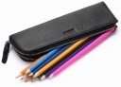
Equipment
Children in year 3 love to bring in pencil cases from home – can I remind you that they only need 1 and it must fit comfortably in their tray! We will be sending home those pencil cases that do not. Golden time will be on a Friday afternoon and children can bring in their own toys to play with. Following the success of ‘Toys on Tuesday’, this will continue and on a Tuesday morning children can bring a toy to play with at play times that day. We encourage you to keep children’s most precious toys at home in case they get lost or broken. Finally, water bottles should be brought to school each day full of fresh water, then taken home again each afternoon. We do not have access to drinking water in the classroom and you can imagine how disruptive it is, if lots of children are continually needing to go to the water fountain in the playground during lesson time.

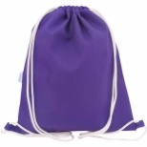
PE
Full PE kit (blue/black shorts, white T shirt and trainers) needs to be in school at ALL times please. There are times when we need to be flexible with the timetable so it’s important to have kit on pegs every day ‘just in case’.
Games will be on a Friday afternoon. In year 3 the children wear their school uniform to school in the mornings and change for their afternoon PE lesson in school. Our other PE slot (for dance or gym) is on a Wednesday afternoon.
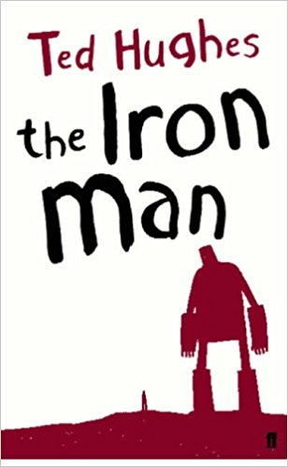Literacy / Topic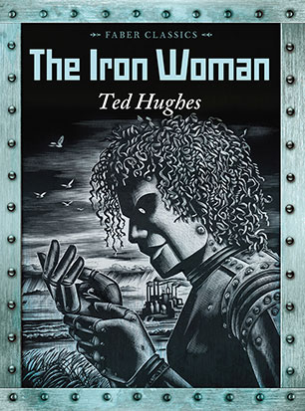
We continue to link together as much of the children’s learning as possible, so our topic, art, dance, music and literacy overlap considerably. In term 3, the topic is ‘The Iron Age’. We will use ‘The Iron Man’ and ‘The Iron Woman’ by Ted Hughes to write about stories set in imaginary worlds, newspaper reports and non fiction recounts. In term 4, we move onto the Romans so Roman myths, newspaper reports and poems form the basis of our literacy / topic. learning.==[p-;ol-p0oo
Numeracy
Multiplying 2 digit and 1 digit numbers
Understanding correlating division

Reinforce adding and subtracting 3 digit numbers.
Reinforce use of money and giving change

Pictograms, bar charts and tables,
Add, compare, subtract lengths
Begin perimeters
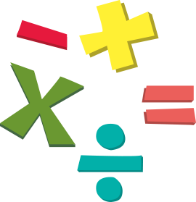

TERMS 1 AND 2
1.Forces and Magnets
2. Plants – part 1
Computing
E-safety
1.We are bug fixers
2.We are vloggers

R.E.
Discovering Christianity; Incarnation – What is the Trinity? Salvation; Why do Christians celebrate Good Friday – when Jesus died?

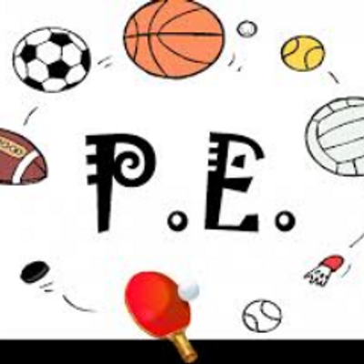

Games - invasion Dance – Iron Man Gym – linking moves
Personal, Social, Health Education
Apple’s Friends – continue module 1.
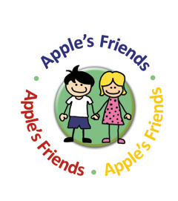
Art / Design Technology
Looking at religious art in RE
Celtic Art – topic
Iron Age artefacts

French
Continue – How old am ?
Schools.
Music
Iron Age composition.

Our reading journals will become more personal to the children this term. They will be encouraged to record their own reading alongside our comments and your comments, to make it a real record of ALL their reading. Please add to this when you hear your child read at home and continue to write on their sign posts, listing the places their reading has taken them. If you have any questions or problems, please do not hesitate to pop in and see us, or make a note in the contact book, so issues can be resolved swiftly. Similarly, we would love to hear of children’s successes, so please share these with us too so they can be celebrated.

